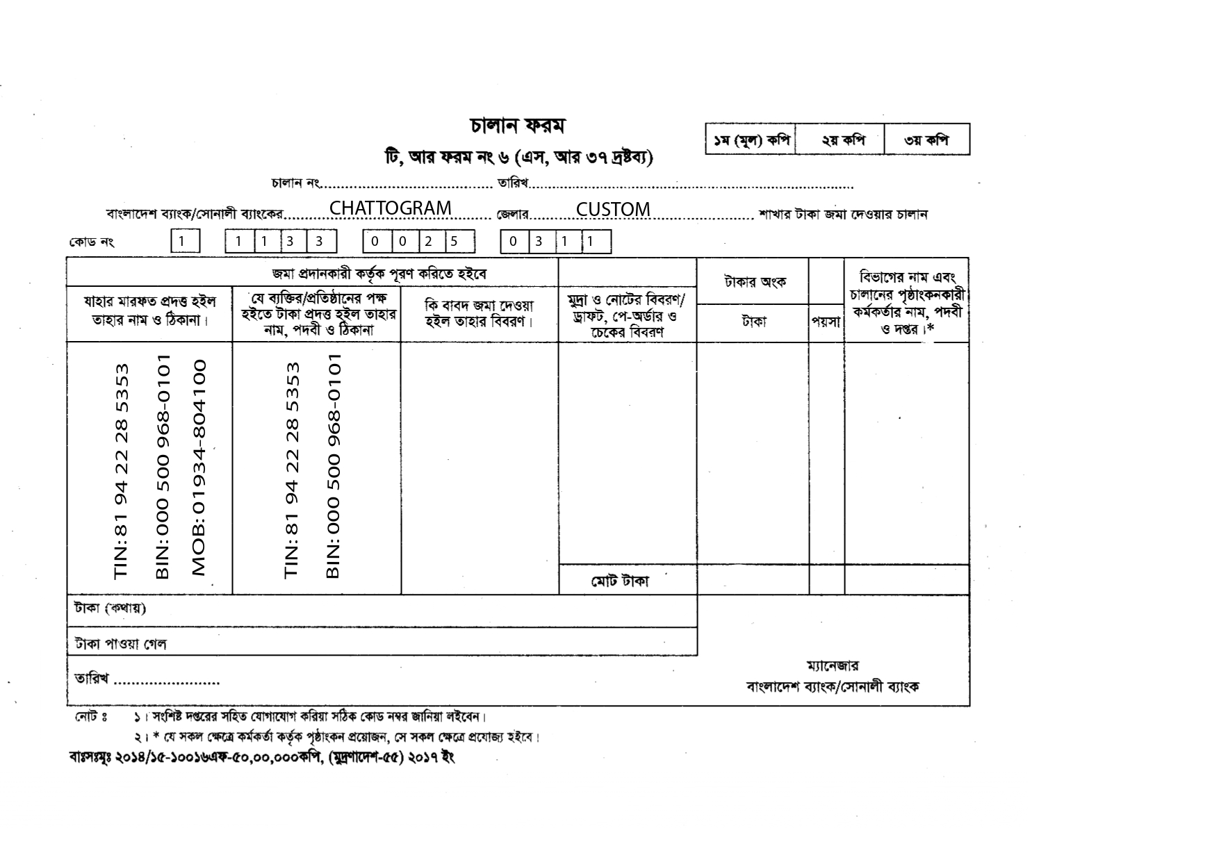

${day}/${month}/${year}

MV. ${vessel}
NRT: ${vsl_nrt} X 10/-
TK: ${chalan15amount} /-
15% VAT ON
LIGHT DUES
TK:${vat15}/- ${vat15}/-
${chalan15amountinword}.

COMMENTS: 15% VAT ON LIGHT DUES OF MV. ${vessel}

